### **Task Description**

Create a dynamic table using React that automatically generates table columns and rows based on the provided array of values. Each object in the array will represent a row, and the keys in the objects will serve as the column headers.

### **Task Output Screenshot**

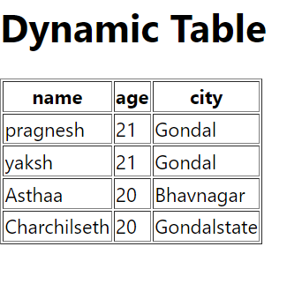

### **Widget/Algorithm Used in Task**

* **React Components**: A functional component is used to render the dynamic table. The table is automatically created based on the structure of the input array.
* **Array of Objects**: The data is provided in the form of an array where each element is an object. The keys of the object are used as column headers, and the corresponding values are displayed as row data.
* **Dynamic Column Generation**:
  + The keys of the first object in the array are used to dynamically generate table headers.
* **Dynamic Row Generation**:
  + The values from each object in the array are used to dynamically generate table rows.
* **JavaScript Map Function**: The map function is used to iterate over the array to generate rows and columns dynamically based on the data structure.
* **Conditional Rendering**: The component includes conditional checks to ensure that if the array is empty or contains no data, an appropriate message is displayed.
* **CSS**: Used to style the table, ensuring proper alignment, borders, and spacing.